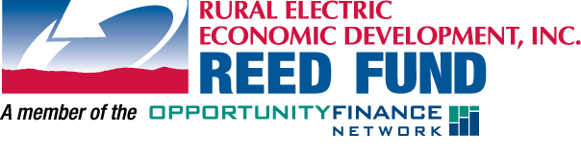
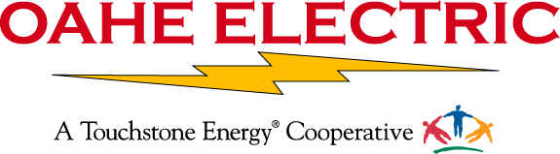

FOR IMMEDIATE RELEASE:
Pierre, SD 3/31/2014
Contact: Rodney Haag
Oahe Electric Cooperative, Inc.
605-962-6243
Marshall Lawn Irrigation, Inc. Receives Loan from Oahe Electric’s REED Fund

Ryan Taylor, new owner of Marshall Lawn Irrigation, Inc. was recently given a helpful hand on 3/31/2014 when Oahe Electric Cooperative, Inc. issued a Rural Electric Economic Development, or REED, loan. The funds will be used to purchase the Marshall Lawn Irrigation business to continue to provide lawn irrigation services in the Pierre area.
Working closely with local banks, other loan funds, state and federal agencies to finance community and economic development projects, Oahe Electric provides gap financing through REED to help business start or expand, create jobs and help communities improve facilities, services and infrastructure.
Oahe Electric Coop Manager, Rodney Haag, says that providing funding to Ryan Taylor to purchase the Marshall Lawn Irrigation business is a great opportunity to positively impact the lives of many. “In today’s economy, employment and economic development continues to be challenging, so being able to assist through the REED Fund is very gratifying for us, knowing we are making a difference in our small communities and rural areas.”
Approximately 88 percent of REED’s lending is established in communities of less than 4,000 people and 95 percent of REED-financed projects have local ownership.
“One of Oahe Electric’s core principles is Commitment to Community and the REED Fund is a good example of how we support local economic development,” says Haag.
If you are planning a new business or looking to expand, or if your community needs financing for facilities or services, please contact Oahe Electric at 605-962-6243 for an application or REED at (605) 256-4536 for more information.

